<https://docs.google.com/document/d/1AWGjze9fYlHYCpcUy-WDkVm-Pjcx8wYT-z5KgTKlHIQ/edit>

Query 1: Movie should have muliple media (Video or Image)

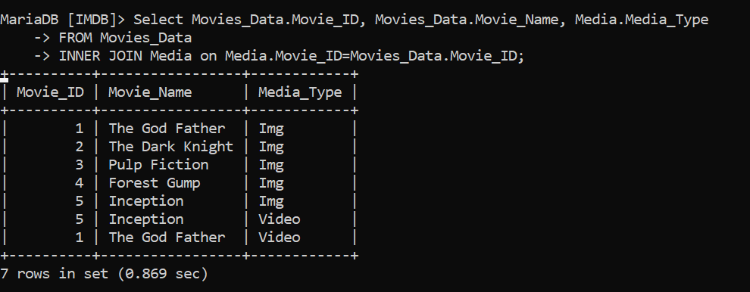

Query 2: Movie can belong to multiple Genre

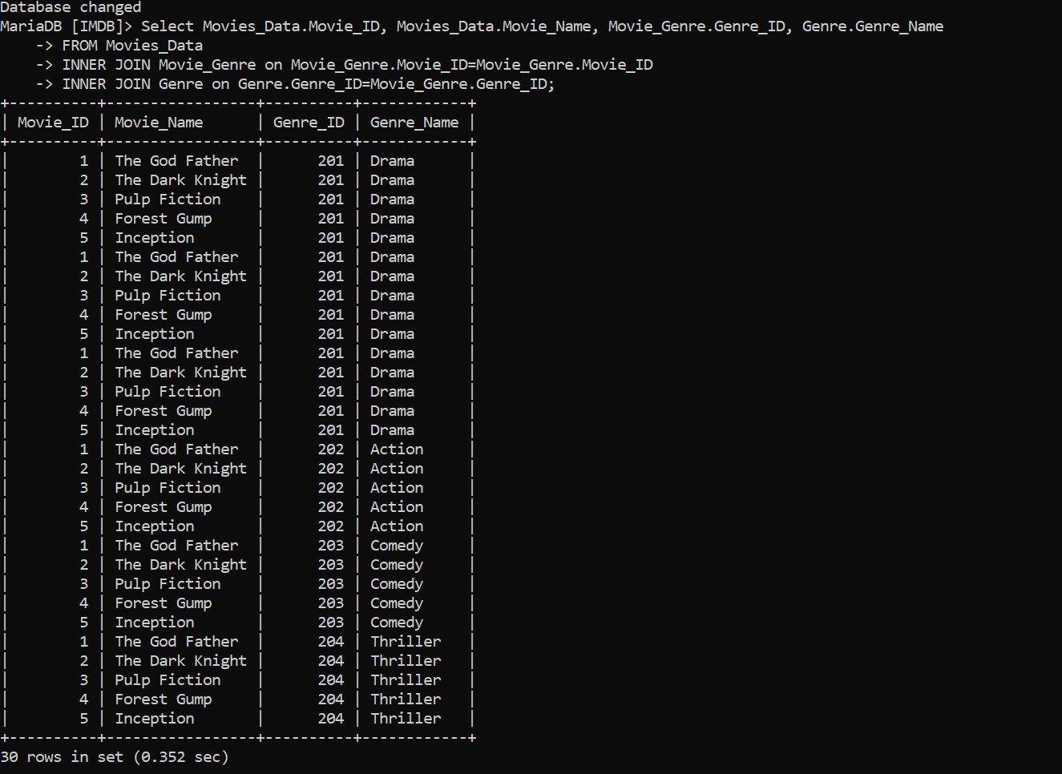

Query 3: Movie can have multiple reviews and review can belongs to a user.

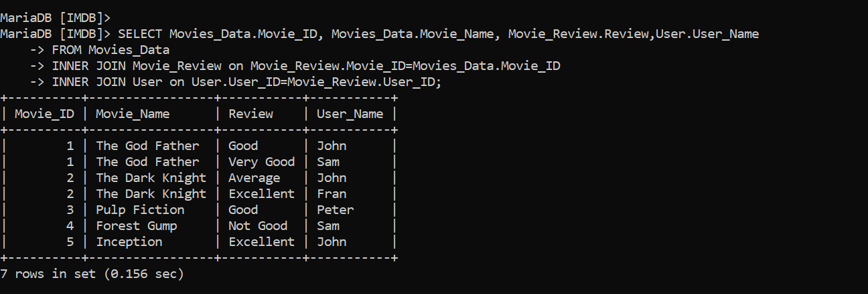

Query 4: Artist can have multiple skills

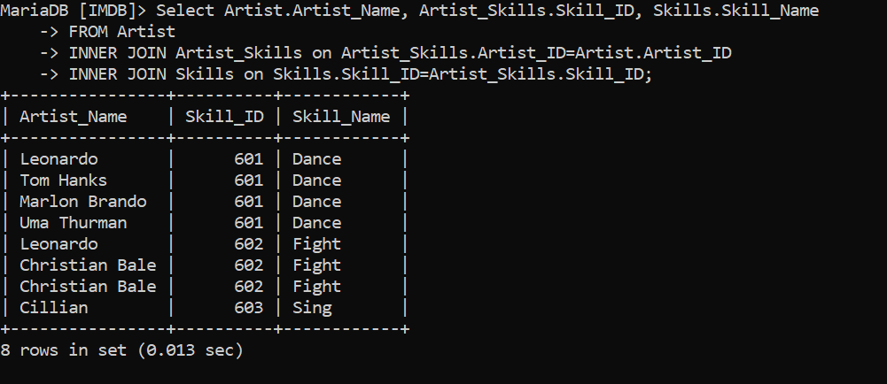

Query 5: Artist can perform multiple role in a single film

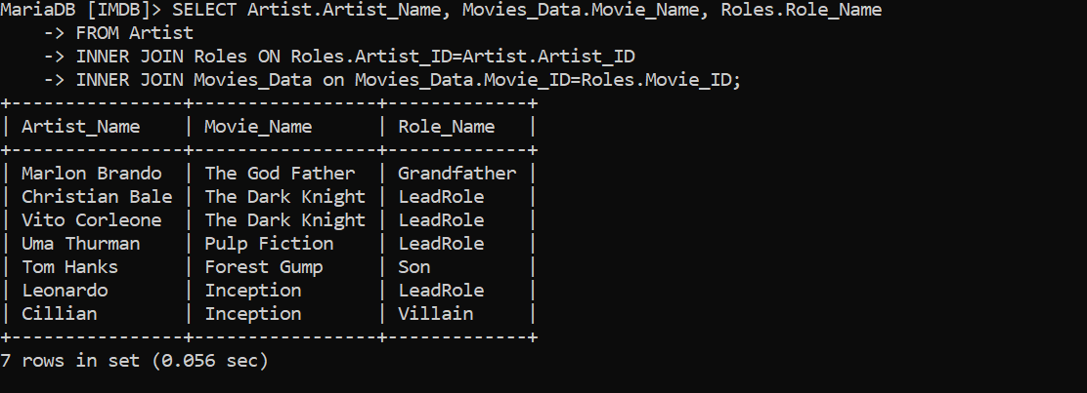

Other Reference Table:



